Report on HEAM CAM 2012
A national level workshop on Characterization of Advanced Materials
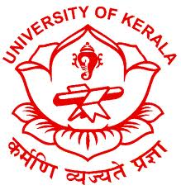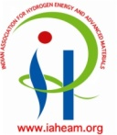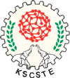
Date: 11 & 12th Oct ‘2012; Time: 09.00 am- 05.00 pm
Venue: Talk & Discussion: Department of Chemistry, University of Kerala
Visit: NIIST, Thiruvananthapuram
In connection with the Platinum Jubilee Celebrations of the University of Kerala, Department of Chemistry organized a two day National Level Workshop on Characterization of Advanced Materials, ‘HEAM CAM-2012’ in association with Indian Association for Hydrogen Energy and Advanced Materials. This program was contributed by eminent scientists from various national research institutions including NIIST, IISER, IIST, VSSC and NPL. The tutorial sessions covered the topics of AFM, TEM, Confocal microscopy, 2D-NMR, Mass Spectrometry, Inductively Coupled Plasma Atomic Emission Spectrometry , Raman Spectroscopy, Tribological Characterization and other related material characterization techniques for better composites and surfaces.
The program was inaugurated by Dr. V.N. Rajasekharan Pillai, Executive Vice President of ‘Kerala State Council for Science, Technology & Environment’ and Ex-officio Secretary of Government of’ Kerala; on Thurs day, the 11th October, 2012 at 9.10 a.m. There were two Theme Talks during the inaugural sessions by Mr. M. Shaneeth (Head, Fuel Cell Section, VSSC (ISRO) and Dr. Bipin Kumar Gupta (National Physical Laboratory, Delhi.
Other technical talks included in the program are:
Dr. Manoj Ramma Varma (NIIST, Trivandrum) - TEM - Methods for Nano Characterization.
Dr. Bipin Kumar Gupta (NPL, New Delhi) - Future Prospects of Advanced Nanomaterials in Strategic Applications.
Dr. Shaijumon (IISER, Trivandrum) - Electrochemical Techniques for Characterization of Advanced Materials.
Dr. Benny K George (VSSC, Trivandrum) - Applications of Raman Spectroscopy.
Dr. Savitha Pillai (NIIST, Trivandrum) - Electrical and Magnetic Properties of Materials - Interdisciplinary Characterization.
Dr. L. Ravisankar (NIIST, Trivandrum) - NMR of Organic Molecules.
Dr. Jobin Cyriac (IIST, Trivandrum) - Applications of Mass Spectrometry.

Many research scholars, young scientists, engineers and faculties participated in the program. Many people suggested and encouraged to propose new programs. The convenor collected the feed back from the participants.

